

MEDIA STATEMENT

FOR IMMEDIATE RELEASE
TO ALL MEDIA HOUSES
14 March 2014

LEGISLATIVE BACKGROUND

The Municipal Finance Management Act (MFMA) section 71(1) require an Accounting Officer of a municipality to submit to the Mayor and the relevant provincial treasury a statement in a prescribed format on the state of the municipality’s budget by no later than the 10th working day after the end of each month. Furthermore section 71(7) requires provincial treasuries to make public a consolidated statement on the state of municipal budgets and those of its entities.

The Gauteng Provincial Treasury presents the state of the municipal financial report for second quarter of 2013/2014 in a conscious effort to assist lawmakers in monitoring and evaluation of service delivery issues; in order to make informed policy directives going forward.

EXPENDITURE MANAGEMENT (REVENUE AND OPERATING BUDGETS)

- The aggregate operating revenue budget of municipalities in Gauteng for the 2013/2014 financial year is R94, 2-billion which indicates an 8% increase when compared to the 2012/2013 adjusted budget of R87-billion. The actual operating revenue to date amounts to R47, 6-billion representing 51% of the consolidated operating revenue budget.

- Service charges accounts for 58% of the aggregate revenue while Property rates and Other revenue accounts for 18% and 9% respectively. Gauteng municipalities managed to contribute 5% of Other own revenue to date.

- Metros accounted for most of the revenue billed amounting to R42, 3-billion or 89% of the aggregate revenue billed to date. While the Locals accounted for R5-billion 10% and the District accounted for only R376-million or 1%.

- The aggregate operating expenditure budget amounts to R91, 8-billion which indicate a 7% increase when compared to the 2012/2013 adjusted budget of R85, 8-billion. The actual operating expenditure to date amounts to R43, 5-billion or 47% of R91, 8-billion.

- The aggregated operating expenditure incurred by Metros is at the highest at R39-billion or 90% of R43, 5-billion, while 10% or (R4, 2-billion) is for the Locals and R297-million is for the Districts.

- Figure 1 below indicates that Bulk purchases and Employee related costs are the highest contributors on the aggregate operating expenditure accounting for 39% and 25% of the aggregated expenditure incurred. Expenditure on Loss on disposal of PPE amounts to R454-million exceeding the budget of R25-million as a result of COJ who incurred an over expenditure of R421,5-million on R50 thousand budget and COT incurring an expenditure of R32,5-million without a budget.

Figure 1: Aggregate Operating Expenditure R’000
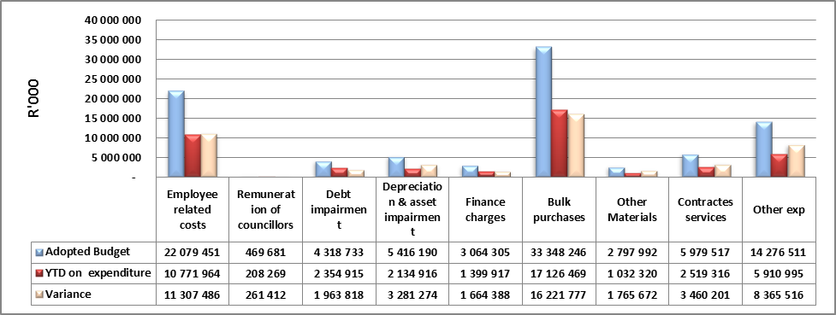

- The Gauteng municipalities operating revenue versus operating expenditure has resulted in a surplus (including non-cash items like debt impairment and depreciation) of R6, 5-billion after capital transfers and contributions.

EXPENDITURE MANAGEMENT (CAPITAL BUDGETS)

- Gauteng municipalities have a collective adopted capital budget amounting to R16, 3-billion which has increased by R3, 1-billion when compared to the R13, 2-billion aggregate adjusted budget of 2012/2013 financial year. The aggregate spending on capital projects is slightly low at R4, 5-bilion or 28%.

- Table 1 below depicts that revenue expenditure is lagging behind for Internal generated funds followed by borrowings. The provincial grants have exceeded the adopted budget by 9% due to spending without a budget by COJ, Merafong City and Midvaal thus the municipalities will have to consider adjusting their budgets.

- Sources of finance indicate that transfers from both National and Provincial government accounts for 51% of the aggregate finance of R4, 5-billion. Borrowings constitute 23% while Internally generated funds and Public contributions and donations accounts for 22% and 5% respectively.

Table 1: Sources of finance funding capital projects- R’000
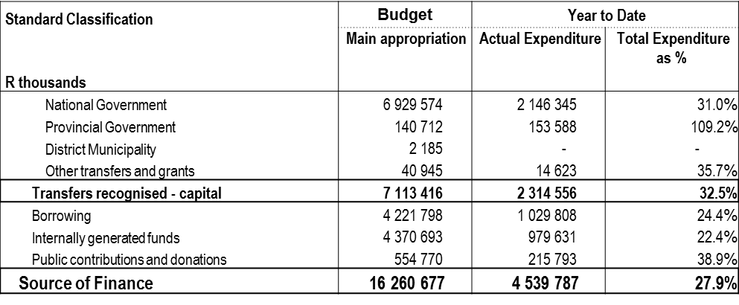

- The capital expenditure as per standard classification indicates that the aggregate R4, 5-billion spent was due to the following projects:

    - Trading service projects accounted for 38% or R1, 7-billion
    - Economic and environmental projects accounted for 35% or R1, 6-billion ,
    - Community and Public safety projects accounted for 28% or R960-million,
    - Governance and Administration projects accounted for 5% or R235-million,
    - Other projects amounted to R30-milion,

- The largest amount of R1.4 billion was spent on Roads Transport, followed by R805 million on the Electricity projects, R615 million on Housing and R481 million on Water.

- However the largest expenditure in terms of % against the budget was for Housing (40%), followed by Roads (31%), Health and Electricity both at (29%)

- The three Metros accounted for 92% of expenditure while Local municipalities accounted for only 8% or R352-million and the District municipalities accounted for only 0.4% or R17-million of the overall capital expenditure. The following was observed on the metros accounted for:

Figure 2 : Capital spending for Metros R’000
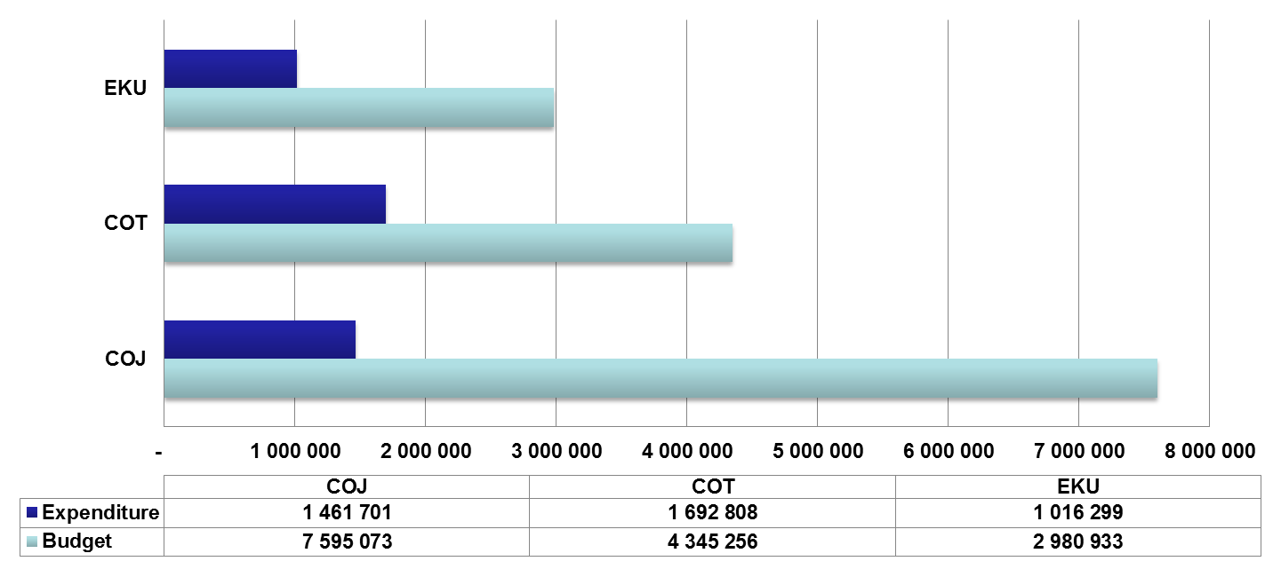

- Overall Transport and Housing projects accounts for most of the expenditure for the Metros. COJ spend on Electricity (R443-million), Housing (R373-million), Roads (R264-million), Water (R259-million) while COT has spent on Roads (R678-million), Waste Water i.e. sanitation (R305-million), Housing (R225-million), Electricity (R146-million). EMM spend on Roads (R441-million), Electricity (R144-million), Water (R100-million), Health (R50-million)

- The Locals and Districts make up 8% (R369-million) of the R4,5-billion total capital expenditure. In terms of the line items, Emfuleni spent R91-million on Development and Planning out of the R6,7-million budget, Mogale City used R18,5-million on Electricity out of R5,5-million budget and R7,8-million on Waste Management (sanitation) out of R4-million budget, Merafong City spent R3,6-million on Water out of R3,1-million budget and Westonaria spent R25-million on Electricity out of R13-million budget. The municipalities will be required to take into consideration the adjustment of the above line items during the adjustment budget process.

- Figure 3 below indicates that Lesedi at 8%, Midvaal at 14%, Randfontein at 17% and Merafong City at 20% are falling behind in terms of capital expenditure. Sedibeng has achieved 70% of their adopted budget while Westonaria’s capital expenditure is at 62%. Trends indicate that capital spending accelerates during the last two quarters of the financial year.

Figure 3 : Capital spending for locals and District municipalities R’000

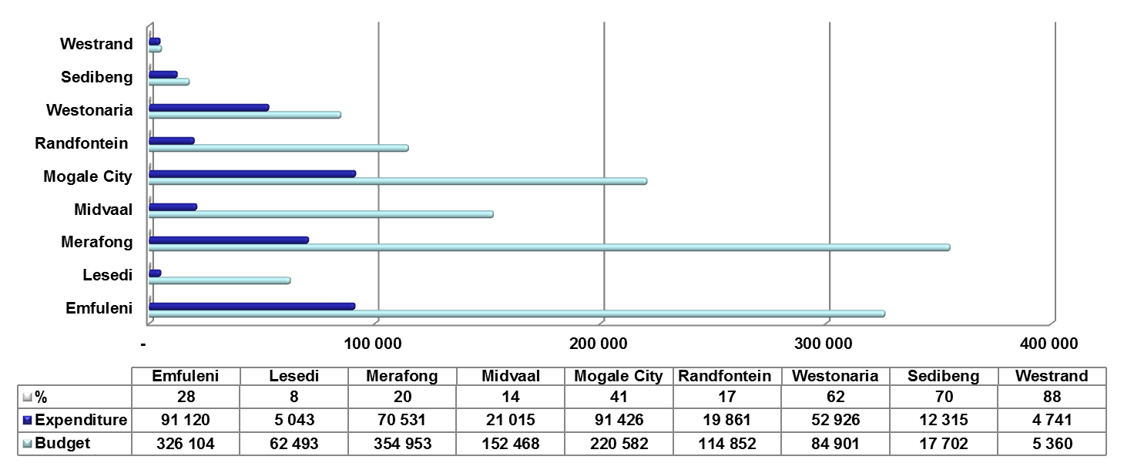

DEBTORS’ BOOK

- Gauteng Municipal Debtors’ Book stood at R39, 8-billion. The current outstanding debtors accounts for 15% or R6, 1-billion. The alarming outstanding debt over 90 days amounting to R30, 5-billion accounting for 77% of the overall debt is a concern which is less likely to be recovered. The ageing of debtors between 31 and 90 days indicates that R3, 2-billion is owed to the municipalities accounting for 8% of the debtor’s book.

Figure 4: Debtors by income source and by customer group as at 31December 2013/14
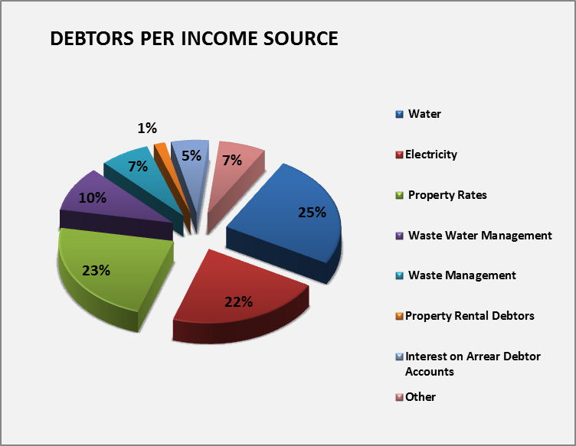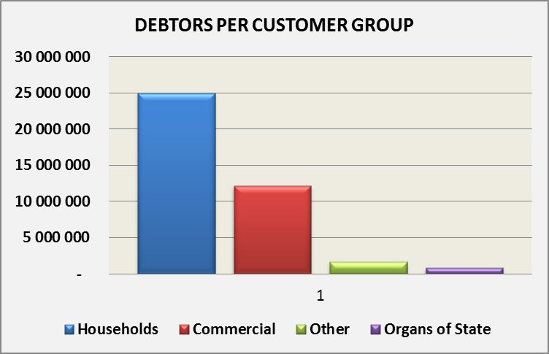

- Figure 4 indicates that Debtors by income source, Water is the highest owed utility at 25%, followed by Property rates and Electricity accounting for 23% and 22%. Waste water management accounts for 10% while Waste management and Other undisclosed income source both accounts for 7% respectively and the rest its spread to other sources.

- Debtors by customer group indicate that Households are the major culprits at 63% followed by Business at 31% and Other undisclosed debtors at 4% of the aggregate municipal debt. Government debt constitutes a mere 2%.

- Gauteng municipalities have indicated that R41-million of their debtors have been written off while Impairment -Bad Debts in terms of Council Policy amounts to R730-million.
- The following outlines the breakdown of the outstanding debtor’s as per Gauteng municipalities;
    - CoJ had the highest debtor’s bill accounting for 44% (R17-billion) of the Debtors’ book,
    - EMM with 25% (R10-billion), while
    - CoT accounted for 15% (R5-billion) the City indicated that R41-millon is the actual bad debts written off to debtors.
    - Emfuleni accounted for 9% (R3-billion),
    - Mogale City (R888-million) and Merafong City both accounts for 2% (R819-million) of all debt owed to municipalities in Gauteng.
    - The remaining 5% is spread across other local municipalities including the district municipalities.

- In order to address revenue collection challenges, Gauteng Provincial Treasury (GPT) has intervened to extend support to municipalities experiencing problems with the revenue value chain and this entail:
- Data analysis
- Customer profiling
- Cash enhancement
- Data cleansing
- Reducing bad debts

- GPT is working on establishing a Revenue Forum as a platform to bring municipal revenue practitioners to look at revenue challenges, innovation and best practices in the industry i.e. public and private sector to enhance revenue.

CASH FLOW

- Gauteng municipalities had opening cash as at the beginning of the financial year of R8, 6-billion with a closing cash balance of R10, 1-billion for the 2013/2014 financial year.

- The aggregated cash receipts for the quarter under review amounted to R50, 2-billion or 50% of the adopted budget of R99, 8-billion. The highest cash inflow was noted from the Cash flow from Operating Activities received from rates and services which amounted to R37, 7-billion or 78% of the adopted budget, while 22% of the aggregated receipts is spread across other receipts.

- Aggregated payment for the quarter amounted to R51, 5-billion or 53% of the adopted budget of R98, 1-billion. Aggregate payments of 83% or R42-billion of these were primarily made up of payments paid to suppliers (R31.6-billion).

CONCLUSION

- GPT in executing its oversight role to municipalities, as mandated by the MFMA commits to continue to support and monitor the progress on municipal spending against the projections and objectives of the 2013/2014 financial year.

Ends

John Sukazi
MEC Spokesperson
0837724885
John.Sukazi@gauteng.gov.za

ABOUT THE GAUTENG PROVINCIAL TREASURY
The Gauteng Provincial Treasury was re-established in April 2012. The Department has set for itself a vision to be an activist, developmental and interventionist Treasury that is a pioneer in efficient resources management and fiscal discipline in South Africa.
For media releases, speeches and news visit the Gauteng Provincial Government’s portal at www.gautengonline.gov.za. Follow us on Twitter @Finance and @GautengTreasury.

